State of the Club
August 20, 2016

The Capital Area Iowa Club is stronger than ever with the help of all the volunteers and members. I was doing some research for an old file and found our agenda from 2009’s board meeting. I look at it and then review what we’re going to discuss this year and see a dramatic change in past performance, planned activities and overall engagement with our national and local alumni. We are definitely coming up with more unique ideas and extending our outreach.
Our membership numbers did suffer a bit since the leadership transition but I’m confident we can start our drives to reach the alumni that are new to the area as well as start re-engaging the military families in the area. I believe we have the right lead for this to not only be able to see our statistics in a better view but also ensuring that new members are receiving their packets in a quick turnaround.
One change I hope you notice is that we have more reports from the different committees which I hope we can continue. I see this as being able to keep track of what’s going on sharing the details with the rest of the board and general membership once it’s approved. We’ll have reports from the Financial, Membership, Sports Teams and Digital committees. As we continue to grow, we can always change these types of reports and add more as needed. Also, if there is an area that we feel needs a report or a group that would like to generate their own, feel free to do so.
Last year, we won the Large Club of the Year and Program of the Year award and based on our previous year’s activities, I think again we are a strong candidate to win again. The other national clubs have definitely taken notice on what we’ve accomplished and are imitating us in a lot of their activities, which can be seen as the sincerest form of flattery. With all your help, I see us continuing to lead the nation and show why we are the best club in the country.
Thanks for all your help!
Kevin

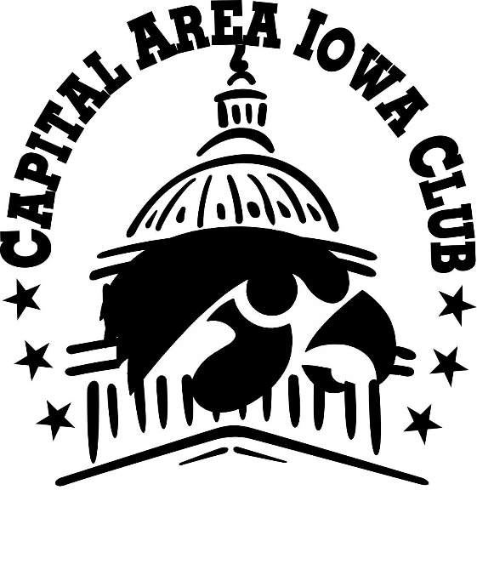
Annual Board Meeting
August 20, 2016
1:00 pm
Crystal City Sports Pub

Agenda
Board Update – 5 mins 3
Membership Report – 10 mins 3
Financial Report – 10 mins 3
Scholarship Report – 10 mins 3
Digital Report – 10 mins 3
Maryland Expansion Report – 10 mins 4
UIAA Report – 10 mins 4
Large Event Discussion – 20 mins 4
Purchase Considerations – 10 mins 4
GameWatch Items – 20 mins 4
Events/Activities – 20 mins 5
Open Discussion 6
Appendix – Committee Reports 6
Sports Report 6
Digital Report 7
Scholarship Report 8
Financial Report 9
Maryland Report 14
UIAA Report 14
Membership Report 15

Board Update – 5 mins
- The following board member’s terms are expiring this year. Please vote on their term extension.
  - Egenia Dixon
  - Brad Moss
  - Kevin Meredith
  - Brian Lein
  - Nicole Gustafson
  - Katy Carenza – Requested not to renew
  - Christine Wirth
- Discussion of candidates and others are welcome; we have 1 open spot but don’t necessarily need to fill it right away.
- Vote for next year’s officers. Current officers are listed below
  - President – Kevin Meredith
  - Vice President – Larry Larson
  - Treasurer – Ann Gordon
  - Secretary – VACANT
- Accreditation/Taxes – Jason Update

Membership Report – 10 mins
- Membership Drive
- Current Numbers
- SWAG details

Financial Report – 10 mins
- Current funds
- Audit
- Budget

Scholarship Report – 10 mins
- Vote for approval to release funds for this year’s scholarship
- 2nd scholarship award consideration
  - Another UI student awarded on non-financial means
  - CAIC member for CE or grad school

Digital Report – 10 mins
- Website Redesign and Hosting Request– Lisa, Tim, Christine, Kevin
- Website Administrations – Kevin
- Newsletter - Christine
- Social Media

Maryland Expansion Report – 10 mins
- Maryland Gamewatch Locations
- Baltimore Day in Inner Harbor
- Big Ten Kickball team

UIAA Report – 10 mins
- Monthly leadership meetings report
- Club Leadership Workshop on Homecoming weekend
- Homecoming float for club members

Large Event Discussion – 20 mins
- Skorton Reception – Alumni Anniversary
- VIP List Generation – done after meeting

Purchase Considerations – 10 mins
- Pennants for bars – see attached for potential design
- New Fall T-shirt – reuse old designs for new shirts

GameWatch Items – 20 mins
- Football Raffles
  - CCSP – need volunteers
  - Public – need volunteers
- Night games
  - 9/10 – Iowa State @ 7:30pm
  - 11/5 – PSU @ 7:30pm
  - 11/12 – Michigan @ 8:00pm
- Gamewatch Theme Days
  - Iowa State (9/10) – CyHawk Day (invite combined gamewatch at one bar?)
  - North Dakota (9/17) – Baltimore Day (travel to Baltimore for game and then hit an Orioles game that evening)
  - Northwestern (10/1) – Homecoming in DC (promotion will be come to DC homecoming if you can’t make it to IC. Special drawings or something)
  - Minnesota (10/8) – Jr. Hawkeye Club Day at CCSP (w/bouncy house, games, and other idea/events for kids during the game)
  - Purdue or Wisconsin (10/15 or 10/22) – Hawkeye Bakeoff at Public (depends on kickoff time. Needs to be a noon game if possible)
  - Michigan (11/12) – Donation Day (pick a charity to collect items or money for, formally kids drive)
  - Illinois (11/19) – Chili Bowl | Donation Day 2 (need volunteers to help promote this. Been declining for last couple years)
- Expansion sites – will share in mailings and newsletter/website as non-DC area gamewatch locations
  - Baltimore | Abby Burger– Larry will represent board along with two volunteers in Baltimore, Nate and Raelyn
  - Richmond
  - Virginia Beach

Events/Activities – 20 mins
- Spring/Summer Review
  - Honor Flights – Christine Wirth
  - Service Event | Anacostia Watershed cleanup - Christine *UIAA Driven
  - Junior Hawkeye Bouncy House at CCSP – Kevin
  - Big Ten Night (Cubs series)
  - Orioles game - Larry
  - Summer Intern Buddy Program – Ann and Jeanette
  - White House Tour - Cori
  - Student Send-off/Re-Gamewatch *UIAA driven – Not happening
- Fall Scheduled/Planned
  - State of Iowa Happy Hour for Iowa State game – 9/8/16?
  - Honor Flights – Need new lead
  - Skorton Reception – 9/13/16
  - Baltimore Day – Gamewatch/Orioles game – 9/17/16
  - Rutgers Game – 9/24/16
  - BigTen Golf Outing – 10/9/16
  - Volleyball @ College Park – 10/14
  - Bye Weekend Activity? Possible letter writing campaign in honor of Marlene English– 10/29/16
  - Field Hockey @ College Park – Nov 3-6
  - Penn State Game – 11/5/16
  - Theme Gamewatches (see above)
- Winter/Spring Ideas
  - Engineering dinner – Feb
  - Basketball/Wrestling Gamewatches
  - BigTen NCAA Basketball Tournament – 4/8/17-4/12/17
  - Kennedy Center event – need help choosing one
- Other Opportunities
  - Another shared event with State Society of Iowa
  - Wine tour
  - Other group tours to places in DC

Open Discussion

Appendix – Committee Reports

Sports Report
By Tim Kennelly
Softball
Due to attrition going back to the 2015 season and low recruitment numbers the Capital Area Iowa Club did not field a Capital Alumni Network Co-Ed Softball team this year after having fielded teams in the 2011, 2012, 2014 and 2015 seasons. If recruitment of new players is successful and there is renewed interest in fielding a team during the 2016 season I will come back to the board to request reinstating the team for the 2017 season. In line with that we are also actively looking for a new head coach to head up this effort under my guidance so please let me know if you have any good candidates.
Flag Football
The Capital Area Iowa Club has fielded a Co-Ed flag football team since 2006 making this upcoming season the 10th Anniversary of CAIC’s participation in the Capital Alumni Network flag football league. Brian Lein will head up the team for his second consecutive season after having relieved Kevin Meredith after the 2014 season, while Tim Kennelly will assist him as assistant coach also in his second consecutive season in the position. Brian will also retain Offensive Coordinator duties in addition to his head coaching duties, while Tim will act as Defensive Coordinator in addition to his role as assistant coach. Brian and Tim will attend the league’s coaches meeting at Crystal City Sports Pub on Monday August 22 to kick-off the season. The first of two practices will be on Tuesday August 23 at Quincy Park in Arlington at 6:30pm. The official league schedule will come out sometime after the coaches meeting on August 22. The league will run from September to November and teams making the playoffs will play during the month of December. We have recruited at least four new players this year including new quarterback following Jeff Bednarczyk retirement following the 2015 season and have retained the majority of the players from the 2015 season. We feel the CAIC flag football team is primed for another successful season in its 10th year.
Sports Committee: Tim Kennelly, Brian Lien

Digital Report
The following committee has been working on redesigning and refining the current digital footprint for the CAIC. This includes the following areas of concentration.
- Website Redesign and hosting – Our current website is hosted by UIAA and UI Foundation. It is a limited service that allows flat files only. It’s also a custom CMS solution that requires knowledge of javascript and html in order to update. We are using Weebly to design and host a new site that would make it easier for non-technical people to update. The downside is that the cost will be about $9.99/month. (test site at http://caictest.weebly.com)
  - Advantages to new site:
    - Able to host forms and signup sheets on the site instead of cobbled together free add-ons.
    - Easy CMS for editing content
    - Ability to host store
    - Allows multiple sites for one hosting service (i.e. one for capitalareaiowaclub.com and another one for kinnickeast.com if we wanted)
    - Ability to integrate Social Media more fluently.
    - Ability to have a managed service
    - No longer tied to UIAA/UI Foundation for support
    - Mobile device compatible with no additional work
  - Disadvantages
    - We will be paying for a service we do not currently pay for
    - Support is with another company
    - Site design limitations of Weebly
- Domain names – We currently own two domains, capitalareaiowaclub.com and kinnickeast.com. Both are hosted at GoDaddy.com but managed by separate individuals. We are working on getting both domains under one management and hosting service. Kevin is leading this effort along with previous partners (Alan Holmes).
- Newsletter – We currently utilize MailChimp for our newsletter needs. This is integrated into the website for members to sign up. Christine and Kevin will continue to manage this function. Please make sure to send any updates for events or notices to them.
- Social Media – We are currently utilizing Twitter, Facebook, and LinkedIn for our social media outlets. Twitter and FB are connected so posts replicate from FB to Twitter. We need more interactions and posts on all outlets to encourage participation from our users. Hashtags have been very successful this year with click rates increasing dramaticly when used for certain events (volunteer day). We’ve also purchased a couple ad bits on Facebook for big events (paid by Kevin for testing purposes).
- Event Calendar – Nicole and Kevin have been testing a Google calendar that will have all our events that can be displayed on the website (old or new) and be able to be downloaded to add to user’s online calendars. This can be seen on their phone if they allow it.
- Instagram/Snapchat – We do not currently have an Instagram or a Snapchat accounts but this should be explored as a potential addition to our portfolio. We will need the same type of connection to both FB and Twitter but also some volunteers to help keep it alive.
Digital Committee: Kevin Meredith, Lisa Schooley, Christine Wirth, Tim Kennelly, Nicole Gustafson

Scholarship Report
The following committee submits the report for our Scholarship initiative aside from the financial aspect (that will come in the Financial Report).
- Last year’s winner was Austin Knott. We will post her news and picture, with her permission, on our site.
- We recommend that we look at sponsoring another scholarship award for one or two different people.
  - An award to another student from DC not based on financial needs. This needs to be explored and determine how this type of thing will be rewarded.
  - An award for a Continuing Education effort from a paid member. Many of our members are in grad school or doing post-school education in the area. Making an award for these types of situations would help create brand awareness of our awards and also encourage membership. Qualifications for scholarship needs to be flushed out
In conclusion, we need some board volunteers to help flesh out these efforts if we choose to continue to explore them and then determine the requirements.
Scholarship Committee: Kevin Meredith, Ann Gordon

Financial Report
Starting balance: $18,303
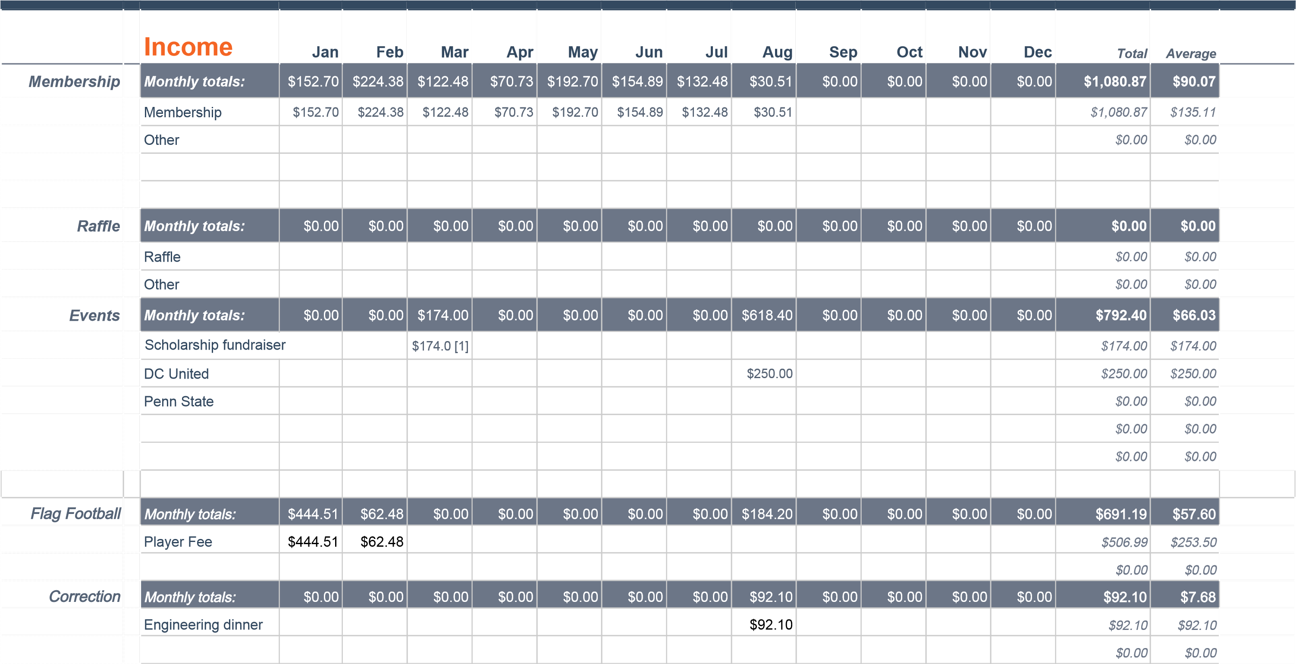

 |  | Expenses |  | Jan | Feb | Mar | Apr | May | Jun | Jul | Aug | Sep | Oct | Nov | Dec | Total | Average
Member Premiu |  | Monthly totals: |  | $0.00 | $0.00 | $0.00 | $0.00 | $0.00 | $0.00 | $0.00 | $0.00 | $0.00 | $0.00 | $0.00 | $0.00 | $0.00 | $0.00
 |  | Cups |  |  |  |  |  |  |  |  |  |  |  |  |  | $0.00 | $0.00
 |  |  |  |  |  |  |  |  |  |  |  |  |  |  |  | $0.00 | $0.00
Scholarship |  | Monthly totals: |  | $0.00 | $0.00 | $0.00 | $0.00 | $0.00 | $0.00 | $0.00 | $0.00 | $0.00 | $0.00 | $0.00 | $0.00 | $0.00 | $0.00
 |  |  |  |  |  |  |  |  |  |  |  |  |  |  |  | $0.00 | $0.00
Flag Football |  | Monthly totals: |  | $0.00 | $0.00 | $0.00 | $0.00 | $0.00 | $0.00 | $150.00 | $0.00 | $0.00 | $0.00 | $0.00 | $0.00 | $150.00 | $12.50
 |  | Equipment |  |  |  |  |  |  |  |  |  |  |  |  |  | $0.00 | $0.00
 |  | Fees |  |  |  |  |  |  |  | $150.00 |  |  |  |  |  | $150.00 | $150.00
 |  | Other |  |  |  |  |  |  |  |  |  |  |  |  |  | $0.00 | $0.00
Membership Pa |  | Monthly totals: |  | $0.00 | $147.12 | $0.00 | $0.00 | $0.00 | $0.00 | $0.00 | $0.00 | $0.00 | $0.00 | $0.00 | $0.00 | $147.12 | $12.26
 |  | Postage |  |  | $84.60 |  |  |  |  |  |  |  |  |  |  | $84.60 | $84.60
 |  | Materials |  |  | $62.52 |  |  |  |  |  |  |  |  |  |  | $62.52 | $62.52
 |  | Other |  |  |  |  |  |  |  |  |  |  |  |  |  | $0.00 | $0.00
Website |  | Monthly totals |  | $0.00 | $0.00 | $0.00 | $0.00 | $30.34 | $0.00 | $0.00 | $0.00 | $0.00 | $0.00 | $0.00 | $0.00 | $30.34 | $2.53
 |  | Kinnickeast.com hosting |  |  |  |  |  | $30.34
Events |  | Monthly totals: |  | $0.00 | $92.10 | $112.01 | $0.00 | $93.16 | $283.61 | $150.00 | $4,698.0 | $0.00 | $0.00 | $0.00 | $0.00 | $5,428.88 | $452.41
 |  | College of Engineering Dinne | r |  | $92.10 [2] |  |  |  |  |  |  |  |  |  |  | $92.10 | $92.10
 |  | Club Board Meetings |  |  |  | $112.0 [3] |  |  | $117.51 |  |  |  |  |  |  | $229.52 | $114.76
 |  | Baltimore Event |  |  |  |  |  | $93.16
 |  | Summer Social |  |  |  |  |  |  | $166.10
 |  | DC United |  |  |  |  |  |  |  | $150.0 [4] | $102.00
 |  | Penn State |  |  |  |  |  |  |  |  | $4,596.00
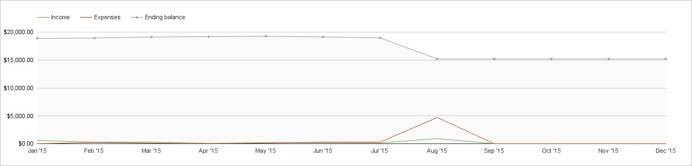
NOTE
ABOUT THIS SHEET
This sheet generates a summary of your spending based on data in the 'Expenses' and 'Income' tabs.
Please don't edit this sheet.
Make sure you've set a starting balance in the 'Setup' tab before beginning.
It contains formulas and will update automatically.
 | Jan '15 | Feb '15 | Mar '15 | Apr '15 | May '15 | Jun '15 | Jul '15 | Aug '15 | Sep '15 | Oct '15 | Nov '15 | Dec '15 | Total | Average
Income | $597.21 | $286.86 | $296.48 | $70.73 | $192.70 | $154.89 | $132.48 | $925.21 | $0.00 | $0.00 | $0.00 | $0.00 | $2,656.56 | $332.07
Expenses | $0.00 | $239.22 | $112.01 | $0.00 | $123.50 | $283.61 | $300.00 | $4,698.00 | $0.00 | $0.00 | $0.00 | $0.00 | $5,756.34 | $959.39
Net saving [5] | $597.21 | $47.64 | $184.47 | $70.73 | $69.20 | -$128.72 | -$167.52 | -$3,772.79 | $0.00 | $0.00 | $0.00 | $0.00 | -$3,099.78 | $193.85
Ending bala [6] | $18,900.59 | $18,948.23 | $19,132.70 | $19,203.43 | $19,272.63 | $19,143.91 | $18,976.39 | $15,203.60 | $15,203.60 | $15,203.60 | $15,203.60 | $15,203.60 |  | $17,466.32
Income | Jan '15 | Feb '15 | Mar '15 | Apr '15 | May '15 | Jun '15 | Jul '15 | Aug '15 | Sep '15 | Oct '15 | Nov '15 | Dec '15 | Total | Average
Membership | $152.70 | $224.38 | $122.48 | $70.73 | $192.70 | $154.89 | $132.48 | $30.51 | $0.00 | $0.00 | $0.00 | $0.00 | $1,080.87 | $90.07
Raffle | $0.00 | $0.00 | $0.00 | $0.00 | $0.00 | $0.00 | $0.00 | $0.00 | $0.00 | $0.00 | $0.00 | $0.00 | $0.00 | $0.00
Events | $0.00 | $0.00 | $174.00 | $0.00 | $0.00 | $0.00 | $0.00 | $618.40 | $0.00 | $0.00 | $0.00 | $0.00 | $792.40 | $66.03
Flag Football | $444.51 | $62.48 | $0.00 | $0.00 | $0.00 | $0.00 | $0.00 | $184.20 | $0.00 | $0.00 | $0.00 | $0.00 | $691.19 | $57.60
Correction | $0 | $0 | $0 | $0 | $0 | $0 | $0 | $92 | $0 | $0 | $0 | $0 | $92 | $8
Summary
Expenses
 |  | Jan '15 |  | Feb '15 |  | Mar '15 |  | Apr '15 |  | May '15 |  | Jun '15 |  | Jul '15 |  | Aug '15 |  | Sep '15 |  | Oct '15 |  | Nov '15 |  | Dec '15 |  | Total |  | Average
Member Premi |  | $0.00 |  | $0.00 |  | $0.00 |  | $0.00 |  | $0.00 |  | $0.00 |  | $0.00 |  | $0.00 |  | $0.00 |  | $0.00 |  | $0.00 |  | $0.00 |  | $0.00 |  | $0.00
 | Scholarship |  | $0.00 |  | $0.00 |  | $0.00 |  | $0.00 |  | $0.00 |  | $0.00 |  | $0.00 |  | $0.00 |  | $0.00 |  | $0.00 |  | $0.00 |  | $0.00 |  | $0.00 |  | $0.00
 | Flag Football |  | $0.00 |  | $0.00 |  | $0.00 |  | $0.00 |  | $0.00 |  | $0.00 |  | $150.00 |  | $0.00 |  | $0.00 |  | $0.00 |  | $0.00 |  | $0.00 |  | $150.00 |  | $12.50
 | Membership P |  | $0.00 |  | $147.12 |  | $0.00 |  | $0.00 |  | $0.00 |  | $0.00 |  | $0.00 |  | $0.00 |  | $0.00 |  | $0.00 |  | $0.00 |  | $0.00 |  | $147.12 |  | $12.26
 | Website |  | $0.00 |  | $0.00 |  | $0.00 |  | $0.00 |  | $30.34 |  | $0.00 |  | $0.00 |  | $0.00 |  | $0.00 |  | $0.00 |  | $0.00 |  | $0.00 |  | $30.34 |  | $2.53
 | Events |  | $0.00 |  | $92.10 |  | $112.01 |  | $0.00 |  | $93.16 |  | $283.61 |  | $150.00 |  | $4,698.00 |  | $0.00 |  | $0.00 |  | $0.00 |  | $0.00 |  | $5,428.88 |  | $452.41
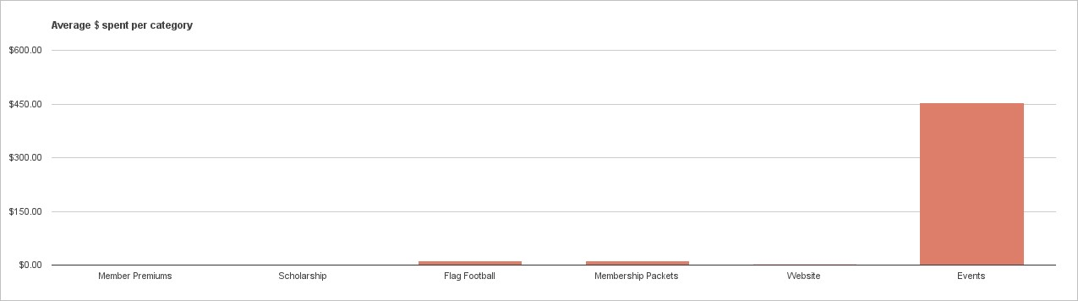

- Check was from 11/15, paid by Heins for the scholarship fund
- Erroneous charge; Kevin Meredith reimbursing CAIC
- Need receipt
- Need receipt
- Total of Income - Expenses
- This total includes the 'Starting Balance' from the 'Setup' tab.

Financial Committee: Ann Gordon

Maryland Report
We're working to reinvigorate the U of I alumni base in Maryland, and specifically in the Greater Baltimore area. This includes most importantly finding a game watch location in Baltimore. Along with Nathan Decker and RaeLyn Debner, we scouted several locations in the Fells Point area earlier this summer. We picked one location and met there again with Kevin recently and were all set, until they pulled the rug out from under us soon thereafter. We're now looking at other locations, which will include other areas of Baltimore and hope to have something soon.
Along with this, we want to have a "Baltimore Day", which will include an Orioles game in the evening on Saturday, September 17. The Hawkeyes play North Dakota St at Noon and the Orioles play Tampa Bay at 7:00 PM. We will plan an event between the games as well.
We also are working on gathering enough people to participate in a Big Ten Kickball tournament in late Oct in the Baltimore area. The date is TBD.
We still have Looney's in Maple Lawn as well for a couple game watches that we could plan during the Big Ten season.
Maryland Committee: Larry Larson, Nate Decker, RaeLyn Debner

UIAA Report
With Jeff Kueter leading the UIAA, the CAIC has become an incubator for many ideas and events. This year, we had Jeff send an email directly to our members thanking them for their support to the CAIC and Iowa and also for their support for the UIAA. The UIAA expects us to be the example for other clubs in the nation for events and idea generation.
UIAA have started monthly club leader conference calls since April and we have attended when possible. The purpose of these meetings are to share the ongoing efforts at the UIAA level, allow leaders to ask questions and share ideas, and help organize a collective national movement for several UIAA endorsed efforts such as the Student Sendoff and the Volunteer Day.
Planned activities this fall is to have clubs participate in a homecoming float in Iowa City like the CAIC did a few years ago. They also have the club leader workshop that same weekend for anyone interested in learning more about being a club leader.
As a national board member, I hope to bring back news and information to share with the rest of the CAIC board. If you have any questions about the national board, please let me know.
UIAA Committee: Kevin Meredith, Larry Larson

Membership Report
Iowa Club Database Information
Numbers were derived based on the last time (by year) dues were paid
Database Total - 411
Current Members
Renewed – 16’ – 35 (Family-13, Single-22)
Renewed – 15’ - 85 (Family-30, Single-55)
Non-Current Members
Year
2014 - 59
2013 - 75
2012 - 56
2011 - 68
2010 – 28
2009 - 1
Blank - 4

Membership Committee: Brian Lien, Tim Kennelly

